Exponent Properties

$$a^{0}=1, a≠0$$
$a^{1}=a$ or $a=a^{1}$
$$a^{m}a^{n}=a^{m+n}$$
$${\left(a^{m}\right)}^{n}=a^{mn}$$
$${\left(ab\right)}^{n}=a^{n}a^{n}$$
$$a^{-n}=\frac{1}{a^{n}}$$
$$\frac{1}{a^{-n}}=a^{n}$$
$$\sqrt[n]{a}=a^{\frac{1}{n}}$$

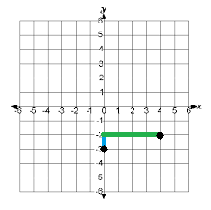
Lines and Linear Functions
Slope-Intercept Form: $y=mx+b or f\left(x\right)=mx+b$, where m represents slope and b represents y-intercept (where line crosses y-axis).
Slope: Given two points $\left(x_{1}, y_{1}\right)$ and $\left(x_{2}, y_{2}\right)$the formula is $m=\frac{y_{2}-y_{1}}{x_{2}-x_{1}}=\frac{\text{rise}}{\text{run}}$
(x₁, y₁)
(x₂ y₂)
rise
run

Quadratic Functions
Quadratic Formula (to solve $ax^{2}+bx+c=0$): $x=$ $\frac{-b±\sqrt{b^{2}-4ac}}{2a}$
Factoring Formulas (used to solve/find zeros):
Examples:
$x^{2}-a^{2}=(x+a)(x-a)$ $x^{2}-4=\left(x+2\right)\left(x-2\right)$
$x^{2}+\left(a+b\right)x+ab=\left(x+a\right)\left(x+b\right)$ $x^{2}+11x+30=\left(x+5\right)\left(x+6\right)$

Sequences
Arithmetic: $x_{n}=a+d(n-1)$
Geometric: $x_{n}=ar^{(n-1)}$

