Lines and Coordinate Geometry
Distance: $d=\sqrt{{\left(x_{2}-x_{1}\right)}^{2}+{\left(y_{2}-y_{1}\right)}^{2}}$
Midpoint: $\left(\frac{\left(x_{2}+x_{1}\right)}{2}, \frac{\left(y_{2}+y_{1}\right)}{2}\right)$
Given any two points, $\left(x_{1},y_{1}\right), \left(x_{2},y_{2}\right)$
Slope: $m=\frac{\left(y_{2}-y_{1}\right)}{\left(x_{2}-x_{1}\right)}$
a
b
x
Geometric Mean
Triangles
Geometric Mean: $\frac{a}{x}=\frac{x}{b}$
Law of Sines: $\frac{a}{\sin{A}}=\frac{b}{\sin{B}}=\frac{c}{\sin{C}}$
Law of Cosines: $a^{2}=b^{2}+c^{2}-2bc\cos{A}$
Law of Sines/Cosines
$b^{2}=a^{2}+c^{2}-2ac\cos{B}$
C
b
a
$c^{2}=a^{2}+b^{2}-2ab\cos{C}$
B
A
c
Polygons
Sum of Interior Angles: $\left(n-2\right)180$
One Interior Angle: $\frac{\left(n-2\right)180}{n}$
One Exterior OR Central Angle: $\frac{360}{n}$

Circles (more on back)
Equation of a Circle: ${\left(x-h\right)}^{2}+{\left(y-k\right)}^{2}=r^{2}$
With center (h, k) and radius r
Length of Arc: $\frac{n}{360}$ $∙2πr$
Where n is the degrees of the central angle
Area of Sector: $\frac{n}{360}$ $∙πr^{2}$

Probability
Conditional: $P\left(A | B\right)=P(A+B)÷P(B)$
Addition Rule: $P\left(A or B\right)=P\left(A\right)+P\left(B\right)- P(A+B)$
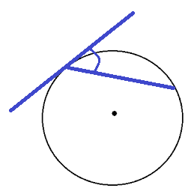
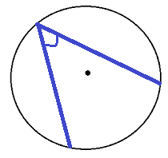
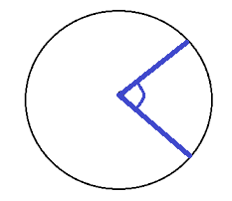
A
Angle = arc ÷ 2
A
Angle = arc ÷ 2
A
Angle = arc

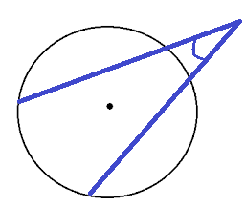
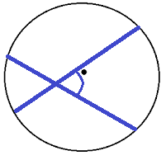
A
Angle = $\frac{\text{far}-\text{near}}{2}$
A
Angle = (sum of arcs) ÷ 2

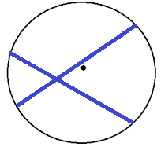
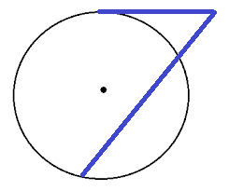
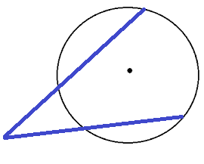
a
c
b
d
$$a∙c=b∙d$$
A

B
D
$$\left(A+B\right)B=D^{2}$$
B
A
D
C
$$\left(A+B\right)B=\left(C+D\right)D$$

Surface Area Formulas
r
$$SA=4πr^{2}$$
h
r
l
$$SA=πr^{2}+πrl$$
h
r
$$SA=2πr^{2}+2πrh$$

h
w
l
$$SA=2lw+2wh+2lh$$
l
$$SA=B+\frac{1}{2}Pl$$

